EXPERIMENT 15
Design and Simulation of an IoT-Based Smart Agriculture System
Aim
To design and simulate an IoT-based smart agriculture system using MATLAB by monitoring soil moisture, temperature and humidity and controlling irrigation automatically.
Procedure
- Open MATLAB and create a new script.
- Define the number of sensor nodes and sampling interval.
- Set the soil moisture threshold.
- Enter soil moisture, temperature and humidity readings.
- Check the soil moisture against the threshold.
- Turn the simulated pump ON when moisture is below the threshold.
- Calculate packet count, data size and transmission time.
- Calculate pump operating time and energy.
- Plot sensor readings and pump status.
MATLAB Program
clc;
clear;
close all;

% Input parameters
N = 5;
moisture_threshold = 30;
sampling_interval = 10;
simulation_time = 60;

packet_size_bytes = 100;
data_rate_bps = 50000;
pump_power_W = 20;

% Simulation time
time = 0:sampling_interval:simulation_time-sampling_interval;

% Sensor readings
soil_moisture = [25 27 29 31 32 28];
temperature = [32 32.2 32.5 32.1 31.8 31.5];
humidity = [65 64 63 64 66 67];

% Irrigation control
pump_status = soil_moisture < moisture_threshold;
pump_on_time_s = sum(pump_status)*sampling_interval;

% Communication calculations
samples = length(time);
total_packets = N*samples;
total_data_bytes = total_packets*packet_size_bytes;
total_data_bits = total_data_bytes*8;

transmission_time = total_data_bits/data_rate_bps;

% Energy calculation
pump_energy_J = pump_power_W*pump_on_time_s;
pump_energy_Wh = pump_energy_J/3600;

% Display results
fprintf('Total Packets: %d\n',total_packets);
fprintf('Total Data: %d bytes\n',total_data_bytes);
fprintf('Transmission Time: %.3f seconds\n',transmission_time);
fprintf('Pump ON Time: %.1f seconds\n',pump_on_time_s);
fprintf('Pump Energy: %.2f J\n',pump_energy_J);
fprintf('Pump Energy: %.4f Wh\n',pump_energy_Wh);

% Sensor readings table
Results = table(time',soil_moisture',temperature', ...
humidity',pump_status', ...
'VariableNames',{'Time_s','SoilMoisture_pct', ...
'Temperature_C','Humidity_pct','Pump_ON'});

disp(Results);

% Soil moisture graph
figure;
plot(time,soil_moisture,'-o');
hold on;
plot(time,moisture_threshold*ones(size(time)),'--');
xlabel('Time (seconds)');
ylabel('Soil Moisture (%)');
title('Soil Moisture Monitoring');
grid on;
hold off;

% Temperature graph
figure;
plot(time,temperature,'-o');
xlabel('Time (seconds)');
ylabel('Temperature (C)');
title('Temperature Monitoring');
grid on;

% Humidity graph
figure;
plot(time,humidity,'-o');
xlabel('Time (seconds)');
ylabel('Humidity (%)');
title('Humidity Monitoring');
grid on;

% Pump status graph
figure;
stairs(time,double(pump_status),'-o');
xlabel('Time (seconds)');
ylabel('Pump Status');
title('Automatic Irrigation Control');
ylim([-0.2 1.2]);
yticks([0 1]);
grid on;
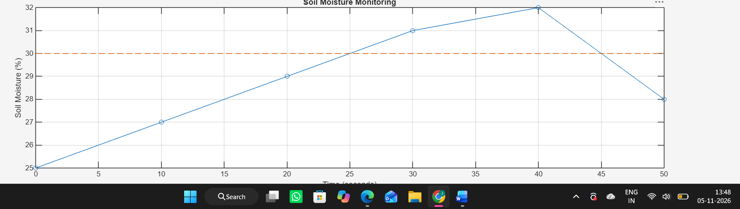
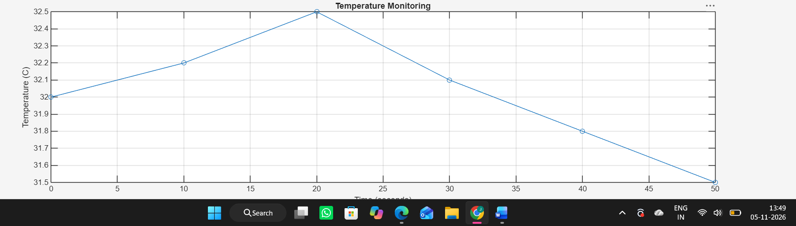

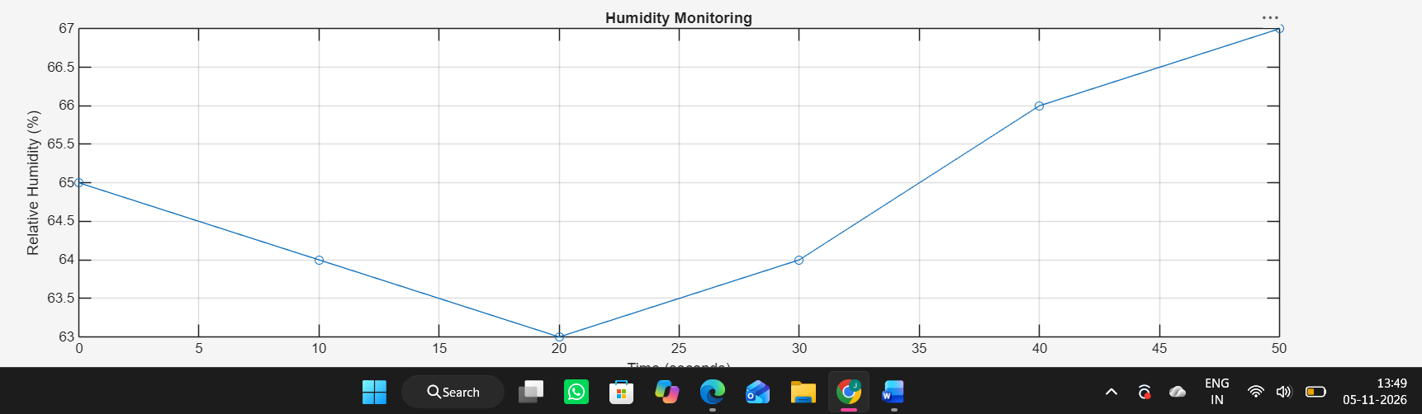

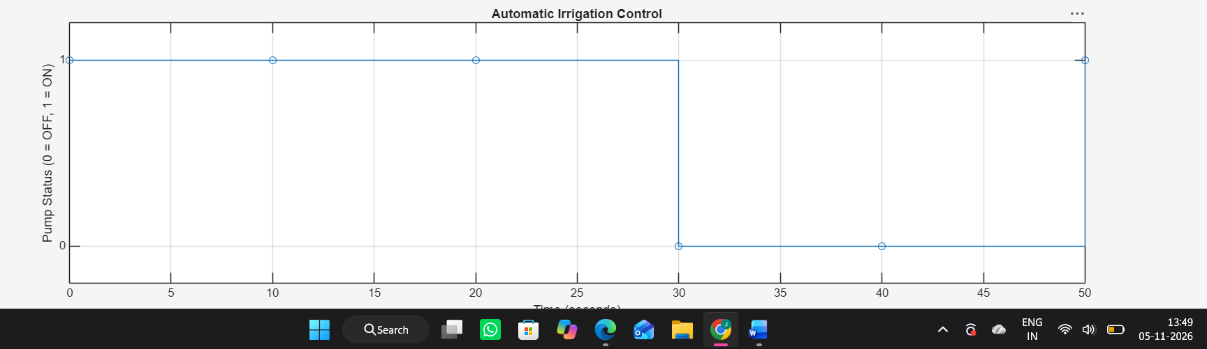

Result
The smart agriculture system was successfully simulated using MATLAB. Soil moisture, temperature and humidity were monitored. The pump turned ON when soil moisture was below 30% and OFF when it reached or exceeded 30%. Packet transmission and pump energy consumption were also calculated.

